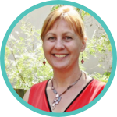 | Melanie Price  Psycho-Oncology Award  2023 Nomination Form | 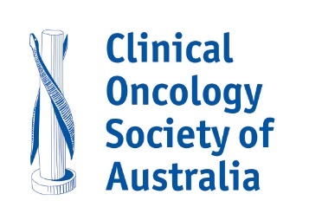
This Award recognises the highest level of contribution to psycho-oncology from amongst the membership of COSA and PoCoG. In 2019 we acknowledged our colleague Melanie Price and named the Australian Psycho-Oncology Award in her honour.
In choosing the recipients of this award, regard is given to the nominee’s achievements and ongoing contribution to the discipline of psycho-oncology in Australia.
The selection criteria are:
- Demonstrated excellence and leadership in their field
- Significant contribution to the discipline of psycho-oncology in Australia
- An inspirational role model for the psycho-oncology community
- Have worked in Australia in the field of psycho-oncology for a substantial period of time
- Membership of COSA and PoCoG
- Self-nominations will not be accepted
Checklist – each nomination should include:
☐ An explanation of the nominee’s work in the area of psycho-oncology care and/or research
☐ An evaluation of the accomplishments of the nominee
☐ Review and critical appraisal of the nominee’s work from two individuals.
For further information about this Award, please contact Dr Laura Kirsten, Chair of the COSA Psycho-Oncology Group Laura.Kirsten@health.nsw.gov.au
Please return the completed nomination form along with supporting documents listed above by email to cosa@cancer.org.au with Melanie Price Psycho-Oncology Award in the subject line.
Nominations close 5:00pm (AEST) Monday 3 July 2023.
Nominee
Title (Mr, Mrs, Ms, Dr, Prof, etc.): | Surname:
Given Names:
Profession:
Position/Title:
Organisation/Institution:
Contact number: | Email:
Does the nominee know about this nomination? Yes or No:

Nominator
Name:
Signature: | Date:
(An electronic signature or email acknowledgement is acceptable)

Please return the completed nomination form along with supporting documents listed above by email to cosa@cancer.org.au
Nominations close 5:00pm (AEST) Monday 3 July 2023.
Previous Award recipients
2021 Professor Gail Garvey
2019 Ms Kim Hobbs
2017 Professor David Kissane
2014 Professor Jane Turner
2012 Professor Afaf Girgis AM

The award is presented in partnership with | 