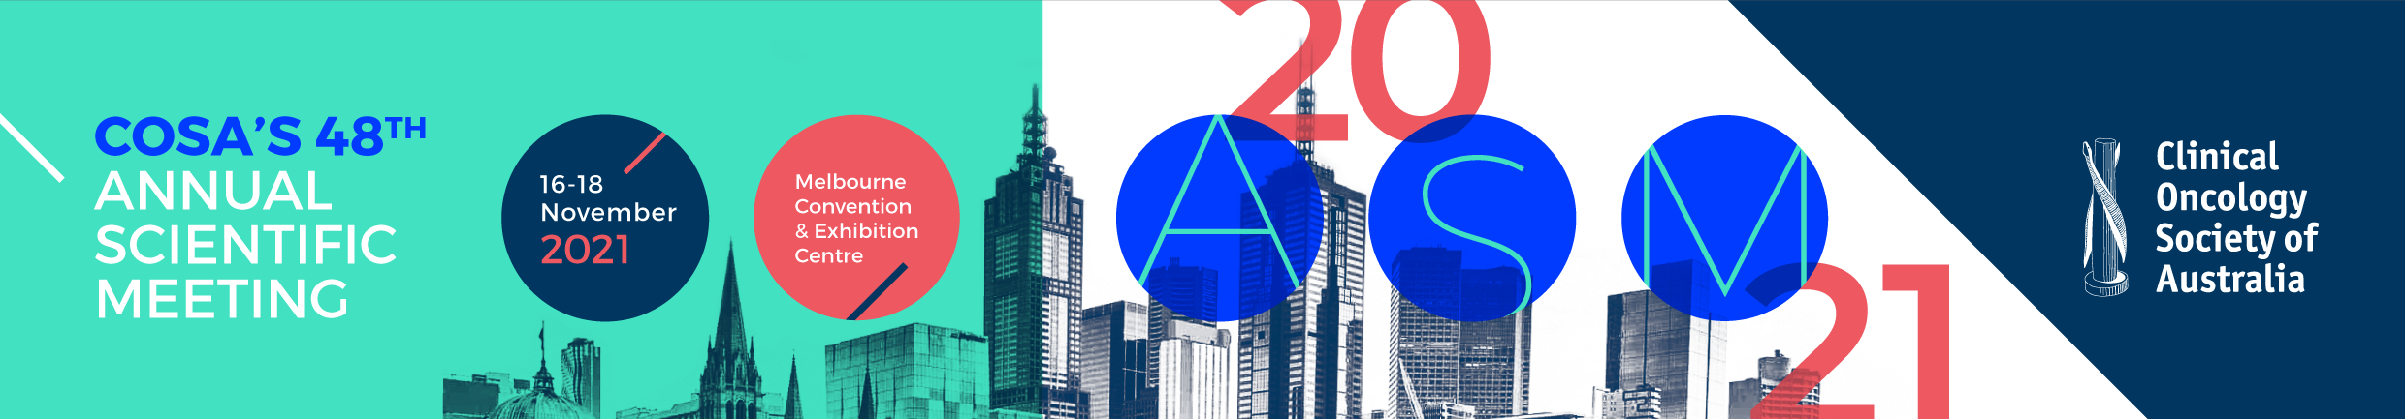
COSA TRAVEL GRANT
APPLICATION FORM 2021
Call for Applications
COSA is pleased to call for travel grant applications from members to attend the Annual Scientific Meeting (ASM) in Melbourne 16-18 November 2021.
Each grant will be up to the value of $1,000 and is to be used for expenses incurred in attending the ASM. Please note you will be reimbursed after the event.
Please note: In an effort to fund as many applications as possible in previous years, complimentary registration was
offered in lieu of cash reimbursement due to the overwhelming number of applications received.
Applications close: Friday 13 August 2021
Title (A/Prof/Dr/Ms/Mrs/Mr) |  | Given Name |  |  |  |  |  | Surname
Organisation |  |  |  |  | Department
Address
Suburb |  |  |  | State |  |  |  | Postcode
Telephone |  |  |  | Fax |  |  |  | Mobile
Email
Abstract Title
I am a financial member of the COSA |  |  | Yes or No
Eligibility Criteria
To be considered for a COSA travel grant you must:
- be a current COSA financial member, valid for at least 12 months prior to this application
- have an abstract accepted for presentation at the meeting (either oral or poster)
- attend the conference
- have not received any COSA travel grant or award in the last 2 years
Submission Instructions
Please send an electronic copy of this form and a brief (1 page) CV via email to cosa@cancer.org.au with the subject line “COSA Travel Grant Application”.
Applications close: Friday 13 August 2021.
Successful applicants will be notified prior to early bird registration closing.
Visit our website for more information on the conference cosa2021.org

