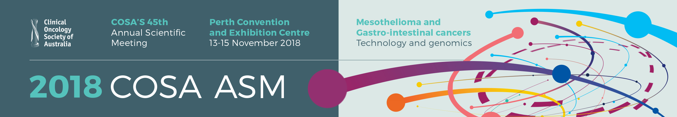
COSA TRAVEL GRANT
APPLICATION FORM 2018
Call for Applications
COSA is pleased to call for travel grant applications from financial Society members to attend the Annual Scientific Meeting (ASM) in Perth 13-15 November 2018.
Each grant will be up to the value of $1,000 and is to be used for expenses incurred in attending the ASM. Please note you will be reimbursed after the event.
Applications close: Friday 17 August 2018
Title (A/Prof/Dr/Ms/Mrs/Mr) |  | Given Name |  |  |  |  |  | Surname
Organisation |  |  |  |  | Department
Address
Suburb |  |  |  | State |  |  |  | Postcode
Telephone |  |  |  | Fax |  |  |  | Mobile
Email
Abstract Title
I am a financial member of the COSA |  |  | Yes or No
Eligibility Criteria
To be considered for a COSA travel grant you must:
- be a COSA financial member for a period of 12 months directly prior to this application
- have an abstract accepted for presentation at the meeting (either oral or poster)
- attend the conference
- have not received any COSA travel grant or award in the last 2 years
Submission Instructions
Please send an electronic copy of this form and a brief (1 page) CV via email to cosa@cancer.org.au with the subject line “COSA Travel Grant Application”.
Applications close: Friday 17 August 2018.
Successful applicants will be notified prior to early bird registration closing.
Visit our website for more information on the conference http://cosa2018.org

