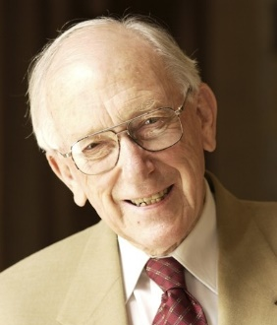 | Tom Reeve Award for Outstanding Contribution  to Cancer Care  2022 Nomination Form
The Tom Reeve Award, offered annually by COSA, formally recognises a national leader who has made a significant contribution to cancer care.
To be eligible nominees must:
- have made a significant contribution to cancer care through research, clinical leadership and/or community service
- have made a substantial contribution over a relatively long period of time
- be nominated by a COSA member and have support from a member of COSA Council
- be an Australian resident
Checklist – each nomination should include:
An explanation of the nominee’s work in the area of cancer control or research
An evaluation of the accomplishments of the nominee
Two letters of reference from individuals outside the nominee’s institution (where applicable). These letters should contain a critical appraisal of the nominee’s work
Please return the completed nomination form along with supporting documents listed above by email to cosa@cancer.org.au
Nominations close 5:00pm (AEST) Monday 1 August 2022.
Nominee
Title (Mr, Mrs, Ms, Dr, Prof, etc.): | Surname:
Given Names:
Profession:
Position/Title:
Organisation/Institution:
Contact number: | Email:
Is the nominee an Australian resident? Yes or No:
Does the nominee know about this nomination? Yes or No:

Nominator
Name:
Signature: | Date:
(An electronic signature or email acknowledgement is acceptable)
COSA Council Nominator
Name:
Signature: | Date:
(An electronic signature or email acknowledgement is acceptable)

Please return the completed nomination form along with supporting documents listed above by email to cosa@cancer.org.au
Nominations close 5:00pm (AEST) Monday 1 August 2022.

Previous Award recipients
2021 Professor Michael Barton OAM
2020 Professor Sanchia Aranda AM
2019 Professor Ian Olver AM
2018 Professor Grant McArthur
2017 Emeritus Professor William McCarthy AM
2016 Professor Fran Boyle AM
2015 Professor David Currow
2014 Professor John Zalcberg OAM
2013 Professor Ian Frazer AC
2012 Professor David Ball AO
2011 Professor Phyllis Butow AM
2010 Professor John Forbes AM
2009 Distinguished Professor Patsy Yates AM
2008 Professor Lester Peters AM
2007 Professor Martin Tattersall AO
2006 Professor Alan Coates AM
2005 Emeritus Professor Tom Reeve AC CBE

