 | Phyllis Butow  New Investigator in  Psycho-Oncology Award  2023 Nomination Form | 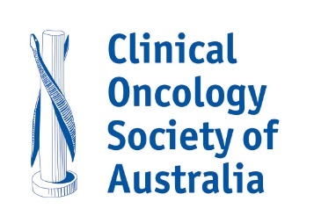

This Award recognises research achievements and potential for an ongoing contribution to the discipline of psycho-oncology in Australia. In 2021 COSA named the award in the honour of Emeritus Professor Phyllis Butow AM in recognition of her leadership and generous mentoring of so many psycho-oncology researchers in Australia and internationally.
In choosing the recipient of the New Investigator in Psycho-oncology Award, regard is given to the nominee’s research achievements and potential for ongoing contribution to the discipline of psycho-oncology in Australia.
The selection criteria are:
- No more than five years from completion of post-graduate, fellowship or equivalent specialist training (PhD, DCP, MD or equivalent)
- Demonstrated excellence in their field
- Contribution to the discipline of psycho-oncology in Australia
- Have worked in Australia in the field of psycho-oncology
- Membership of COSA and PoCoG
- Self-nominations will not be accepted
- Individuals less than five years from completion of post-graduate, fellowship or equivalent specialist training - PhD, DCP, MD or equivalent
Note: the award is linked to professional attainment rather than to age
Checklist – each nomination should include:
☐ Nominee’s curriculum vitae, with details of specific completion dated of degrees and post-graduate training
☐ Letter of nomination specifying why the nominee meets the award description above
☐ Two letters of support from other individuals to whom the nominee is known, also specifying why the nominee meets the award description above
☐ Copies of up to four publications that represent the nominee’s research work
For further information about this Award, please contact Dr Laura Kirsten, Chair of the COSA Psycho-Oncology Group Laura.Kirsten@health.nsw.gov.au

Please return the completed nomination form along with supporting documents listed above by email to cosa@cancer.org.au with Phyllis Butow New Investigator Psycho-Oncology Award in the subject line.

Nominations close 5:00pm (AEST) Monday 3 July 2023.

Nominee
Title (Mr, Mrs, Ms, Dr, Prof, etc.): | Surname:
Given Names:
Profession:
Position/Title:
Organisation/Institution:
Contact number: | Email:
Does the nominee know about this nomination? Yes or No:

Nominator
Name:
Signature: | Date:
(An electronic signature or email acknowledgement is acceptable)

Please return the completed nomination form along with supporting documents listed above by email to cosa@cancer.org.au
Nominations close 5:00pm (AEST) Monday 3 July 2023.
Previous Award recipients
2021 Dr Joanna Fardell
2019 Dr Ben Smith
2017 Dr Ursula Sansom-Daly
2014 Dr Addie Wootten
2012 A/Prof Haryana Dhillon

The award is presented in partnership with

